Introduction

Ever since the days of Quake, developers have extensively used light mapping as the closest they can get to realistic lighting. (Nowadays true real-time Per-Pixel-Lighting is slowly replacing light maps).
In this article I am covering a simple but quick light mapper that we developed in 2001 for use in our internal projects at Dhruva Interactive. The method is not as precise as radiosity based techniques, but nevertheless produces results that are effective and usable.
This article will be useful for people who havenï¿½t got light maps into their engine / level yet, and are looking for relative resources.
Overview
This document explains / demonstrates the process of creating light maps for use in games or any graphics application.
Objectives
The goal of this document is to explain the process of creating light maps. It describes how light map lumels are calculated and how the final pixel color is determined.
However, this document does not cover any of the latest ï¿½per-pixelï¿½ techniques that are possible with the new generation graphics chipsets.
Assumptions
It is assumed that the reader has in depth knowledge of 3D game programming and the essentials of 3D graphics, especially lighting, materials, 3D geometry, polygons, plane, textures, texture co-ordinates, etc.
Also, this document explains only the process of light map evaluation or generation ï¿½ it does not explain how light map texture co-ordinates are calculated. If you do not have light map texture co-ordinates in your mesh yet, then, Iï¿½ve got a simple method to test the light map generation.
Click here to read more on this.
If you are really eager to know the results of a light map based lighting technique before you get on with this article, then click here to go to the demo section, where you can download an interactive demo.

Lighting Basics

You've seen games which look pretty close to real life ambience (I mean, only look wise). The reason for that, is the use of lights. If the game was not "lit", then, it would look less than ordinary. It is the lighting, which makes the player, look at the game again and again. Take a look at what difference, lighting makes:
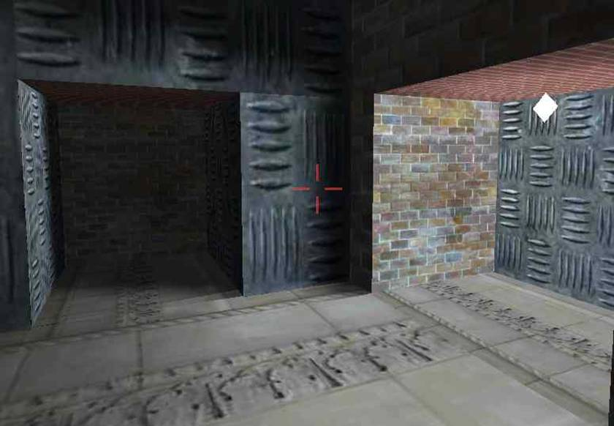
World with light-map lighting. The white rhombus type object (on the right hand side) represents a point light source.

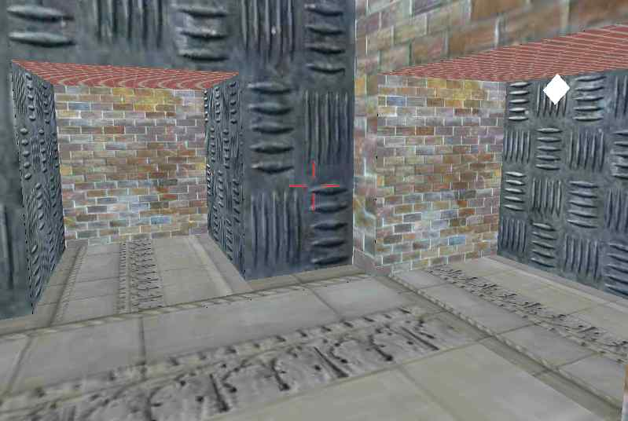
World without any lighting.
The results are impressive, aren't they?
Now that youï¿½ve seen the results, letï¿½s take a look at the different types lighting in practice (as far as the "static world" is concerned).
1. Vertex lighting:
• For every vertex, a color value is calculated, based on how lights affect it.
• The color values will be interpolated across the triangle.
• Triangles / polygons cannot be very large, other wise which visual glitches will be seen.
• Polygons have to be tessellated to a decent level for the output to be good.
• If vertex count goes up, then, calculations also take longer ï¿½ since it is per vertex based.
• Does not incur a load on texture memory (as required for light maps).
• All the calculations are done in real time ï¿½ hence real-time lighting is very much possible.
• Shadow(s) are not correct.
• Can achieve amazing lighting effects.
2. Per-pixel lighting (Real time):
This document does not cover the per-pixel lighting methods that are in practice today, i.e., the effects that are achievable on current generation of graphics cards, like NVIDIA GEForce 3/4, ATI Radeon 8500/9700 and later.
• For every pixel that is going to be drawn, calculate the color value based on how lights affect it.
• Does incur a huge load on the engine.
• It is not practical for a real-time game to use it.
• Accurate shadows are possible (another overhead with collision detection is a certain possibility).
• Can achieve the most realistic lighting possible ï¿½ but is too slow to use in real time games.
3. Per-pixel lighting (light map):
• Realistic lighting can be achieved.
• Dynamic lighting needs a lot more work.
• Can combine with vertex lighting to achieve real-time dynamic lighting.
• Every single bit of expensive lighting calculation is done during pre-process time.
• Hence, no overhead during runtime.
• At run-time, all calculations (color arithmetic) are done by hardware. Hence it is very fast.
• Visual quality of the lighting is directly dependant on the size of the light map texture(s).
• The closest we can get to per-pixel lighting, with such less overhead.
• For every triangle, a diffuse texture map is applied first and then, a light map is usually modulated (multiplied) with it.

Per-pixel Lighting Using Lightmaps

We will be discussing light-map based lighting in the remainder of the document. A light-map is nothing but another texture map. The only difference between a light map and a diffuse map is that, a diffuse map holds plain color values, whereas, a light map holds color values as a result of light(s) affecting the polygons on which this light map was applied. Everything else is the same.
• Light maps textures are mapped to a triangle/polygon using a unique set of texture co-ordinates known as light map texture co-ordinates.
• Resource for light map is loaded the same way as the diffuse textures.
• Each pixel in a diffuse map texture is usually referred to as ï¿½texelï¿½, whereas each pixel in a light map texture is referred to as ï¿½lumelï¿½. We all want to use fancy words ï¿½ donï¿½t we???
Before delving into the process of light map calculation, lets take a look at how a 2D texture is mapped on to a 3D triangle.
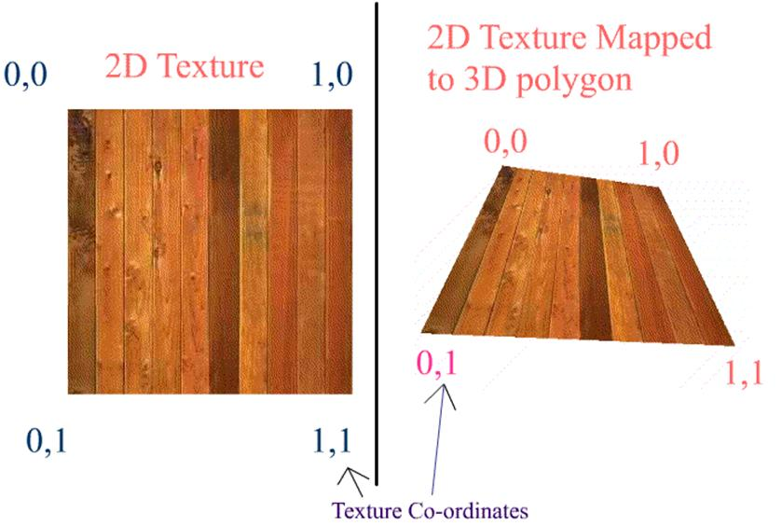
On the left hand side of the above diagram, is a 2D texture (as you would see in any of the image editing tools) of (N x N) dimension. The normalized dimension is also shown.
On the right hand side is a 3D polygon, as you would see in the game, except that the background is missing. The texture co-ordinates are mentioned for each vertex. As you can see, the texture is mapped to the polygon with a mapping ratio of 1:1. i.e. the whole texture is mapped to the polygon at a ratio of 1:1.
Now consider the diagram below. The diagram shows a polygon being mapped or pasted on a 2D texture. This polygon however uses only a part of the texture. So, the mapping ratio is not 1:1. We can observe that the polygon covers a only a part of the area of the complete texture. i.e. this polygon has some pixels from the texture map belonging to it. Hence, more the pixels that this polygon has, the more nicer that this polygon will look. (This is in 3D viewing, considering the camera is neither very close to the polygon nor far from the polygon. We shall ignore MIPMAPS for this discussion).
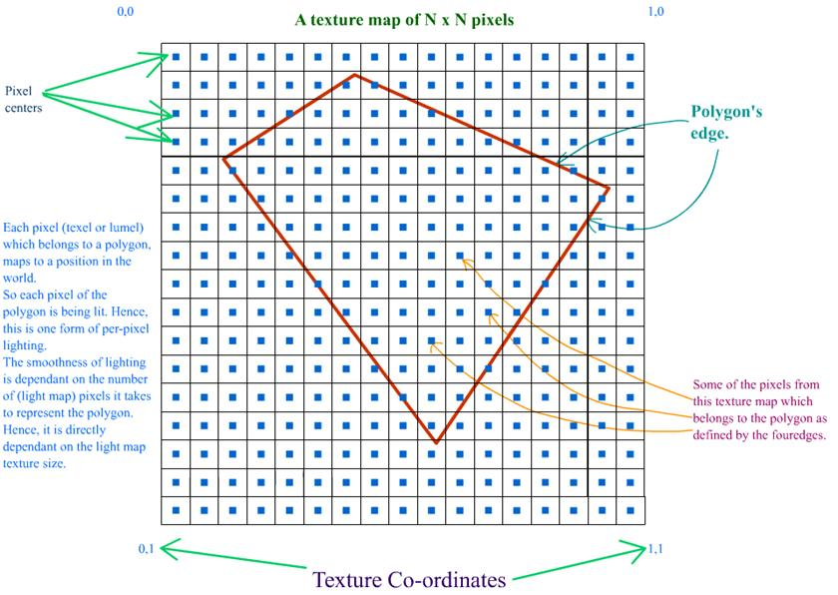
Letï¿½s look at the above diagram closely taking light maps into account. A diffuse map, may or may not be shared by polygons. i.e. a pixel from a diffuse map can be belong to "n" number of polygons. But, for a light map, a pixel belongs to one and only one polygon.
Each pixel in the light map has a corresponding position in the world, with respect to the polygon that it belongs to. You have to understand this concept very well. Since every vertex of a triangle has a position in the world, every light map pixel that this triangle will hold will have a position in the world ï¿½ which will vary uniformly across the length of each edge.
Also, there is a concept of pixel center. Whenever we refer to a pixel, it means the pixel center. A pixel is not a point, but it is a box. Please refer to the diagram below.
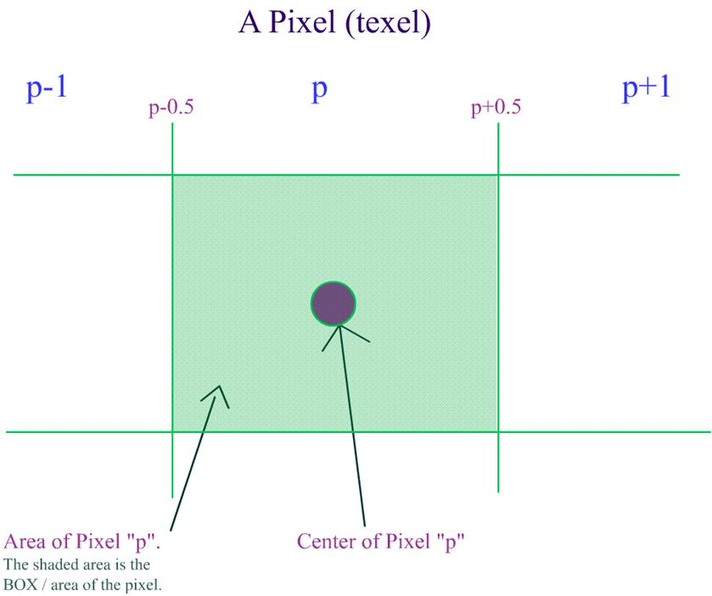
Based on the above criteria, whenever we want a UV co-ordinate for any pixel, it is calculated this way:

x = (w+0.5) / Width
y = (h+0.5) / Height
In the above equations,
w and h = offsets for the current pixel that we are calculating UV co-ordinates for.
Width = width of the light map texture.
Height = height of the light map texture.
This is what is mentioned in the diagram below.
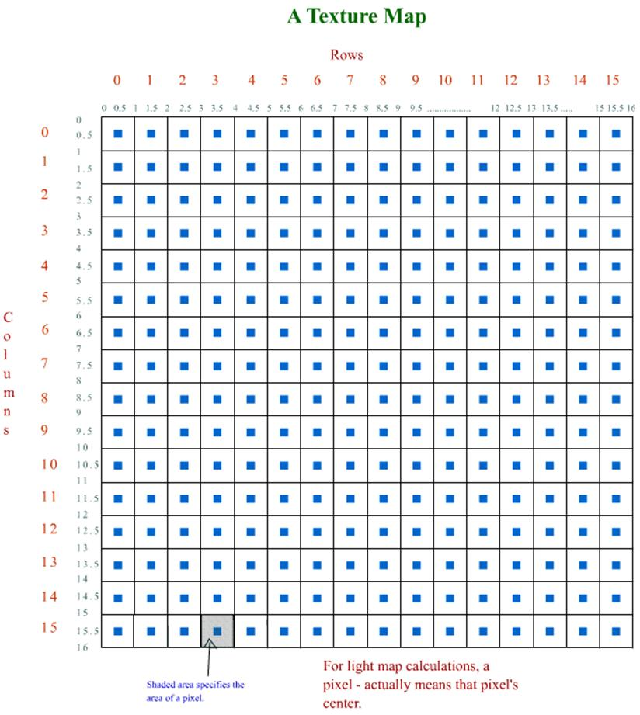
Now, Im trying illustrate what I have said above, in the form of a diagram. First, take a look at the diagram:
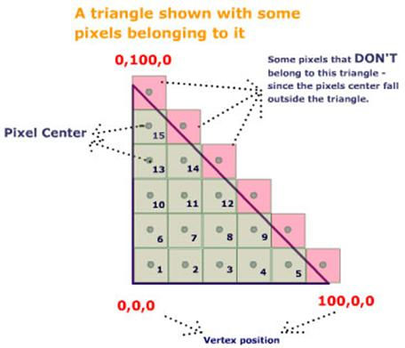
In the above figure, I am hypothetically describing the relationship between the triangle and the (light map) pixels.
In the above figure,
• the triangle is defined by the 3 thick black edges / lines.
• the three vertices of the triangle are (0,0,0) , (0,100,0) and (100,0,0)
• Since the Z co-ordinate for all the three vertices is same, we can safely ignore the Z-component for our calculations.
• Each box inside (and slightly outside) the triangle identify a unique (light map) pixel.
• Remember that a pixel is a box (has area) and not a point.
• Green box means, that the pixel is well with in the triangle and that this light map pixel belongs to this triangle.
• Pink box means that the pixel centers fall outside this triangle and hence these pixels do NOT belong to this triangle.
• Every pixel that belongs to this triangle has been numbered in certain order.
• This triangle contains 15 pixels.
• Our exercise now is to determine the approximate theoretical world position for each pixel just by observing the triangle and the pixels.
Remember, what we are doing now is just based on eye measurements. It is in no way accurate.
This exercise is to just make you understand the relationship between vertex, lightmap texture-cordinates and light map pixels. This exercise should give you an idea of what the "world-position" for a pixel means.
Look at the bottom most line, there are 5 pixels and the width of the edge is 100 units on X axis.
• That means 20 units for each pixel.
• Also, the edgeï¿½s position varies only on X axis. So, Y and Z values remain constant.
• Hence the first pixel would have the X value of 20 (Not accurate by any means).
• First pixelï¿½s position would be (20.0, 0.0, 0.0)
• The second would have a position of (40.0, 0.0, 0.0), third would have (60.0, 0.0, 0.0), fourth would have (80.0, 0.0, 0.0) and the fifth would have (100.0, 0.0, 0.0)
Similarly, try to arrive at the positions for the other pixels.
I'm reminding you again that the above results are NOT correct. That exercise was to make you understand what "world-position" for a pixel means.
Also, from the above diagram, you can decipher that ï¿½ the more (light map) pixels a triangle has, the lesser will be the world-position shift from pixel to pixel ï¿½ and hence results in a smoother output. Try to figure out how?
If you still havenï¿½t understood the concept of pixel center, and world-positions for a pixel, then, please go through this document again from the start. Please do not continue if you are not clear.
Heres an image which shows the result of using a light map.
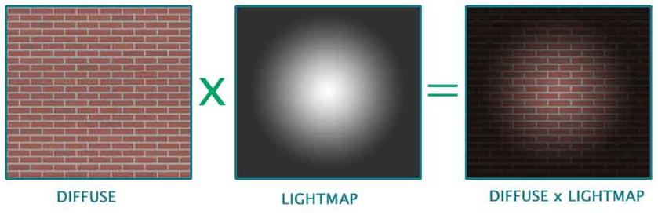

A Simple Lightmap Based Lighting Technique

Now lets get on with the actual process of light mapping. The complete process of calculating light maps is split into three parts. They are:
1. Calculating / retrieving light map texture co-ordinates.
2. Calculating the world position and normal for every pixel in every light map.
3. Calculating the final color for every pixel.
a. Calculating / retrieving light map texture co-ordinates:
This is the very first and basic process. It involves assigning each polygon to a specific area of the light map. This topic in itself is a candidate for a lengthy article. Hence, I'm going to skip this topic and jump to the next one.
However, if you want links to articles that explain this, then, I've provided some in the links section, at the very end of this article.
Also, this is one of the most important processes, since it determines the efficiency of using texture space. This can either be done in an automated process or can be done manually in editing tools such as 3DS Maxï or Maya.
However, if you want a quick way to generate a world to test light maps, then you can do this:
1 Create an empty cube, a pretty large one. (empty, hence collision detection is not required)
2 Assign diffuse and light map texture co-ordinates manually.
3 Even better, you could use one diffuse for all the faces of the cube and use six different lightmaps for each face(polygon) of the cube.
4 This way, you can map the light map to the polygons of the cube with a ratio of 1:1.
5 Create one or two lights at the extreme top ends of the cube.
6 Use this setup to test your light map generation.
In the next level, to test shadow generation, you can add a box at the bottom center of the cube, and add collision detection routines.
b. Calculating the world position and normal for every pixel in every light map:
This is the pre-processing stage of the light map calculation. As you know, each pixel in the light map will map to a position in the world. This is exactly what we need to calculate. As long as the world geometry and the light map texture sizes doesnï¿½t change, this data is static, i.e. it can be calculated once and reused.
This is how it is done. Now consider a triangle like this. Why we have only 2D components for vertex position in the below triangle will be explained in later paragraphs.
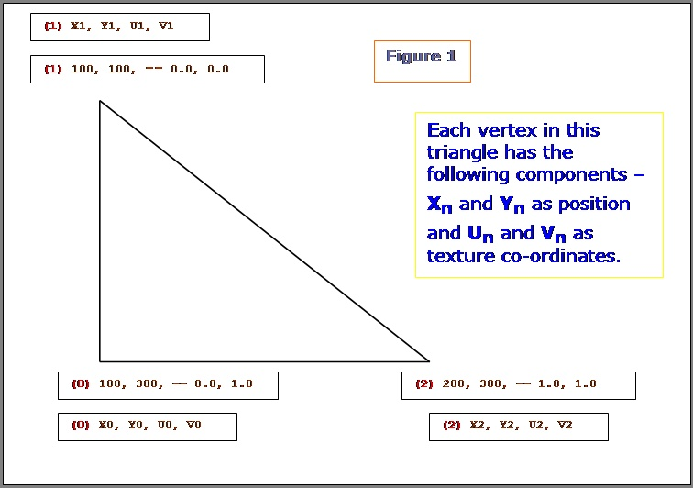
Letï¿½s see what are all the know factors here:
• a. We know the end points of the triangle (2D).
• b. We know the (light map) texture co-ordinates for all the 3 vertices.
What do we need to calculate here: Given a texture co-ordinate value (on or within the 2D triangle), retrieve the 2D position on or within the 2D triangle. We have to do it for every pixel of the light map that this polygon owns. (Remember, a pixel from a light map can belong to one and only one triangle / polygon.) Let's see how we can achieve this.
NOTE: In the following few paragraphs, Iï¿½m using certain equations, illustrations and quotes from Chris Heckerï¿½s article on Perspective Texture Mapping. Please refer to the above said article for more information.
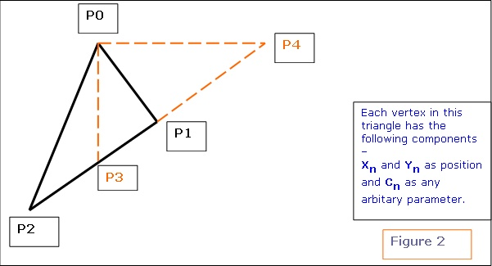
Consider triangle P0, P1, P2 in the above diagram. Each vertex has a screen space (2D SPACE) associated with it i.e. (X, Y). But in addition, there is an arbitrary parameter, C, which is, color for Gouraud Shading, or 1/Z, u/z or v/z for perspective texture mapping. Hence ï¿½Cï¿½ is any parameter we can linearly interpolate over the surface of the two-dimensional triangle. For the derivation, two points P3 and P4 are constructed as shown in the above diagram.
Therefore,

x1 - x2 x4 ï¿½ x2
-------- = --------
y1 ï¿½ y2 y4 ï¿½ y2
and
c1 ï¿½ c2 c4 ï¿½ c2
-------- = --------
y1 ï¿½ y2 y4 ï¿½ y2
We know that y4 = y0 and x3 = x0.
Click here to see the derivation as to how we arrived at equation 1 and 2 mentioned below. For the triangle, we get the following two equations:
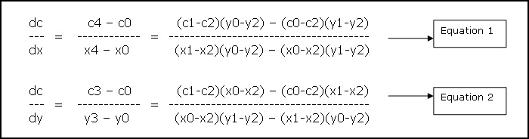
The above two equations tell how much of variable ï¿½Cï¿½ varies w.r.t X and Y. i.e. given a position (x, y) we can calculate ï¿½Cï¿½ for that position. For our lightmap solution, we need just the opposite. We know the texture co-ordinates (i.e. ï¿½Cï¿½) and we need to retrieve the position. I will be using the formulas as mentioned below. These are directly inherited from the above two equations. (Please refer to figure 1 for the variable names)

denominator = (v0-v2)(u1-u2) ï¿½ (v1-v2)(u0-u2)
dp dx (x1-x2)(v0-v2) ï¿½ (x0-x2)(v1-v2)
--- = --- = --------------------------------------
du du denominator
dp dx (x1-x2)(u0-u2) ï¿½ (x0-x2)(u1-u2)
--- = --- = --------------------------------------
dv dv -denominator
dq dy (y1-y2)(v0-v2) ï¿½ (y0-y2)(v1-v2)
--- = --- = --------------------------------------
du du denominator
dq dy (y1-y2)(u0-u2) ï¿½ (y0-y2)(u1-u2)
--- = --- = --------------------------------------
dv dv -denominator

Now get uv position relative to the first vertexï¿½s light map texture co-ordinate.

duv.x = uv->x ï¿½ u0
duv.y = uv->y ï¿½ v0

uv is the pointer to the texture co-ordinate for which the ï¿½world-positionï¿½ has to be computed. U0 and V0 are the light map texture co-ordinates for the first vertex.
Let pos be the pointer to final position.

Equation 3
pos->x = (x0) + (dpdu * duv.x) + (dpdv * duv.y)
pos->y = (y0) + (dqdu * duv.x) + (dqdv * duv.y)

Now we have the 2D position corresponding to the triangle and the UV coordinate.
Let's look at the figure 1 as an example, and try to retrieve the position for a given UV co-ordinate:
Let the UV co-ordinate for which the Position has to be calculated be {0.5, 1.0 } We definitely know that co-ordinates {0.5, 1.0 } fall well within (or on) the triangle.
We get the following values:

dxdu = dpdu = 100
dxdv = dpdv = 0
dydu = dqdu = 0
dydv = dqdv = 200
duv.x = (0.5 ï¿½ 0) = 0.5
duv.y = (1.0 ï¿½ 0) = 1.0

Hence the position is:

Pos->x = 150
Pos->y = 300

You can change the winding order and try ï¿½ you'll get the same result. Only the dxdu, dxdv, dydu, dydv, and duv values will change.
Now, we've retrieved the 2D position w.r.t a UV co-ordinate. But finally, we need a 3D position to do any 3D calculations. How do we do this? Here's the plane equation to the rescue. We know that a plane is represented by the equation: Ax+By+Cz+D = 0. Every polygon / triangle has a plane equation associated with it. Also, we can project any triangle/polygon along two of it's major axis. i.e. we are projecting a 3D triangle to 2D, by ignoring one of itï¿½s axis. This is required, because a texture is 2D whereas a triangle is in 3D space.
Which axis ï¿½ X, Y or Z to ignore? How we choose the axis to ignore is, given the plane normal, choose the two axis that are most aligned to the plane normal. If a, b, c (analogous to x, y, z axis) represent the plane normal, then, find out the maximum of the absolute of these three values, and ignore that axis.
Ex. If plane normal is (0, 1, 0), then, we would choose XZ axis and ignore the Y component. If plane normal is (0, -1, 0), then also, we would choose XZ axis.
Now we'll refer back to figure 1.
If the plane normal for the given triangle in figure 1 was (0, 1, 0), then the (Xn, Yn) values specified for each vertex in the figure, would actually be Xn and Zn. , I've used (Xn, Yn) in the figure to keep the derivation consistent.
Remember, the triangle is still in 3D, but weï¿½re converting it to 2D by ignoring one component.
Look at equation 3. Now, we've the world position of the lumel in 2D co-ordinates. We've to convert it to 3D. So, use the plane equation. Depending on which axis weï¿½ve projected the triangle, we have to use the appropriate equation.
For example: The plane normal was (0.123, 0.824, 0.34).
According to what Iï¿½ve mentioned above, we ignore the Y ï¿½ component. Hence, when we get the 2D position of the lumel, it will be the X and Z components. We need to calculate the Y component.
We have Ax+By+Cz+D = 0.
By = -(Ax+Cz+D)
y = -(Ax+Cz+D) / B.
Thus we have the Y component. Similarly, we can calculate the missing component for other projections also.
First, let's look at the Lumel structure.

struct Lumel
{
D3DXVECTOR3 Position ; // lumel position in the world.
D3DXVECTOR3 Normal ; // lumel normal (used for
// calculating N.L)
DWORD Color ; // final color.
BYTE r, g, b, a; // the red, green, blue and alpha
// component.
int LegalPosition ; // is this lumel legal.
DWORD polygonIndex ; // index of the polygon that it
// belongs to.
} ;

This structure is used for every pixel in every light map. Ex. If the dimensions of a light map are 64x64, then, the memory required to hold the lumel info Would be:
size of each Lumel structure = 40 bytes.
Total size = (64 * 64 * 40) bytes = 163840 Bytes = 160 Kbytes.
This is just a test case. You CAN reduce the memory foot print.
"LegalPosition" member of the Lumel structure, will hold information whether the particular pixel belongs to any polygon or not.
The structure for a vertex displaying a light map would look something like this.

struct LMVertex
{
D3DXVECTOR3 Position ; // vertex position.
D3DXVECTOR3 Normal ; // vertex normal
DWORD Color ; // vertex color.
D3DXVECTOR2 t0 ; // diffuse texture co-ordinates.
D3DXVECTOR2 t1 ; // light map texture co-ordinates.
} ;

The structure for a polygon displaying a light map would look something like this.

struct LMPolygon
{
LMVertex *vertices ; // array of vertices.
WORD *indices ; // array of indices.
DWORD VertexCount, // No. of vertices in the array
FaceCount ; // No. of faces to draw in this
// polygon.

DWORD DiffuseTextureIndex ; // the index in to the diffuse
// texture array

DWORD LMTextureIndex ; // the index in to the light-map
// texture array
} ;

Hereï¿½s the pseudocode for a function called BuildLumelInfo() that actually fills in the world position for every pixel in the light map:

BuildLumelInfo()
{
// this function has to be called for each light map texture
for(0 to lightmap height)
{
for(0 to lightmap width)
{
w = current width during the iteration (for loop)
h = current height during the iteration (for loop)
U = (w+0.5) / width
V = (h+0.5) / height
UV.x = U
UV.y = V
if (LumelGetWorldPosition(/*UV, this light map texture*/)) SUCCEEDED
then
// Mark this lumel as LEGAL.
else
{
// Mark this lumel as illegal ï¿½ in the sense that no triangle uses this pixel / lumel.
}
}
}
}
LumelGetWorldPosition( UV, light map texture )
{
for( number of polygons sharing this light map texture )
{
// do the "Bounding Box" lightmap texture co-ordinate rejection // test.
if( /*UV co-ordinates of the light map do not fall inside the
polygonï¿½s MAXIMUM and MINIMUM UV co-ordinates*/ )
then
//try next polygon ;

// code for the above explanation

if(uv->x < poly->minUV.x) continue ;
if(uv->y < poly->minUV.y) continue ;
if(uv->x > poly->maxUV.x) continue ;
if(uv->y > poly->maxUV.y) continue ;
for( /* number of faces in this polygon */ )
{
/*Get the three vertices that make up this face.
Check if light map UV co-ordinates actually fall inside the polygonï¿½s
UV co-ordinates. This routine is similar to routines like ï¿½PointInPolygonï¿½
or ï¿½PointInTriangleï¿½.
If YES, then call GetWorldPos to get the actual world position in 3D
for this given light map UV co-ordinate.

If NO, then this is not a legal pixel, i.e. this pixel does not
belong to THIS polygon.*/
}
}
}
GetWorldPos(UV uv)
{
// get uv position relative to uv0
duv.x = uv->x - uv0->x ;
duv.y = uv->y - uv0->y ;
// retrieve the components of the two major axis.
// i.e. here we are converting from 3D triangle to 2D.

switch(PlaneProjection)
{
case PLANE_XZ :
// collect X and Z components
break ;
case PLANE_XY :
// collect X and Y components
break ;
case PLANE_YZ :
// collect Y and Z components
break ;
}
// Calculate the gradients from the equations derived above.
// See Equation 3 above.

Now calculate gradients.
i.e. dp/du, dp/dv, dq/du, dq/dv, etc.
// In the following line, I have used a, b, instead of X, Y or Z.
// This is because, depending on the polygonï¿½s plane we
// choose either XY or YZ or XZ components. Hence, a and b map to
// either XY or YZ or XZ components
pos->a = (a0) + (dpdu * duv.x) + (dpdv * duv.y)
pos->b = (b0) + (dqdu * duv.x) + (dqdv * duv.y)
// get the world pos in 3D
// calculate the remaining single co-ordinate based on the polygonï¿½s
// plane.

switch(PlaneProjection)
{
case PLANE_XZ :
// We would have got X and Z as the 2D components.
// calculate the Y component.
y = -(Ax+Cz+D) / B.
break ;
case PLANE_XY :
// We would have got X and Y as the 2D components.
// calculate the Z component.
z = -(Ax+By+D) / C.
break ;
case PLANE_YZ :
// We would have got Y and Z as the 2D components.
// calculate the X component.
x = -(By+Cz+D) / A.
break ;
}
}

The function to build the lumel information is as follows: Remember, as long as the geometry, light map texture co-ordinates and light map texture sizes are constant, this function can be called only once and re-used again and again. This way, if you change a property for a light, then, you don't have to build the whole data base again. All you have to call is the function BuildLightMaps. BuildLumelInfoForAllLightmaps() should be called before BuildLightMaps().

BuildLumelInfoForAllLightmaps()
{
// Do initialization here.

for (number of light maps)
{
// If memory for Lumels not allocated, then,
// Allocate memory to hold the lumel info for this particular
// light map.

BuildLumelInfo(this_light_map) ; // Calculates the
// world position for all the lumels.
}
}

- c. Calculating the final color for every pixel:
This is the last process involved in the calculation of light maps. Here we fill out the actual pixel values in every light map. I'll first give the pseudo code here which calculates the color for every pixel in the light map.

BuildThisLightMap()
{
for(0 to lightmap height)
{
for(0 to lightmap width)
{
lumel = current lumel ;
if(lumel is not legal)
then
try next lumel.
for( number of lights )
{
// cos theta = N.L

dir = lightPosition - lumel->Position
dot = D3DXVec3Dot(&lumel->Normal, &dir) ;
// if light is facing away from the lumel, then ignore
// the effect of this light on this lumel.

if( dot < 0.0 )
try next light ;
distance = distance between lumel and light source.
if(distance > light range)
try next light ;
// Check Collision of ray from light source to lumel.

if( collision occurred )
then
{
// lumel is in shadow.
continue ;
}
// GetColorFromLightSource.
// Write color info to lumel.
}
}
}
}

As you can see, the pseudo code explains itself pretty well. It's the basic light calculation. I wonï¿½t spend too much time there. Let's look at the procedure which starts the process of calculating colors for all the light maps.

BuildLightMaps()
{
for (number of light maps)
{
BuildThisLightMap () ; // does all the lighting calculations.
BlurThisMap() ; // blurï¿½s the light map.
FillAllIllegalPixelsForThisLightMap() ; // fills all the illegal

// lumels with the closest
// color ï¿½ to prevent bleeding when
// bi-linear filtering is used.

WriteThisLightMapToFile() ; // finally write the lightmap colors
// to file.
// I write it in a 24-bit BMP format.

}
}

Lets look closely at what the two functions BlurThisMap and FillAllIllegalPixelsForThisLightMap do.
No matter whatever we do, if youï¿½ve NOT turned on any filtering, then, "pixels" can be seen in the final rendered image. This is very unrealistic and can easily annoy the player / viewer. Hence, we try to smoothen out the "pixels".
You can use any filter you want for smoothing. Iï¿½m using a BOX filter in my code. This is exactly what my BlurThisMap does.

BlurThisMap()
{
for(0 to height)
{
for(0 to width)
{
w = current width during the iteration (for loop)
h = current height during the iteration (for loop)
current_pixel = GetCurrentPixel(w,h)
// Get neighboring 8 pixels for current_pixel, ignoring the
// illegal pixels.

sum_color = Add color from the neighboring legal pixels.
// calculate the average.
final_color = sum_color / no. of neighboring legal pixels.
SetCurrentPixelColor(w, h, final_color) ;
}
}
}

Actually, if youve turned on Bi-Linear filtering in your game, then, the effect of "pixels" are reduced. But, still we smoothen out the map, to make the final image appear really smooth. If the final result (in the game) looks good without blurring the light map texture, then, you may skip the BlurThisMap procedure.
There's another problem if we use bi-linear filtering. It's the "bleeding" problem.
When bi-linear filtering is turned on in your game, then, whenever a pixel is chosen, the final color will not be the color from the pixel alone, but, the average of the pixels around it. (average of how many pixels - depends on the kind of filtering used.)
As you know, some of the pixels in our texture map will be illegal. It means, that particular pixel belongs to no polygon.
Usually, the color of any illegal pixel will be zero, since no color calculation is being done for that pixel.
So, while rendering, whenever a pixel is chosen, the average of the color around that pixel will be considered. In this process, even the "illegal" pixels may be chosen. This is why "bleeding" happens.
If we're using bi-linear or tri-linear filtering (which I bet we would be) in ourgame, then, we somehow got to get rid of the illegal pixels.
Actually, we can't get rid of them. What we can do is fill every illegal pixel with a color from the closest "legal pixel". This way, during filtering, it is assured that the closest and most appropriate color is chosen.
This way, most of the "bleeding" problems will be solved. This is what the procedure FillAllIllegalPixelsForThisLightMap does.
One way of solving "bleeding" problem, without having to fill out illegal pixels, is to set the color of all the illegal pixels to ambient color. Even though this gives decent results and is also very inexpensive, it's not the correct way of doing it. Maybe, you can consider this method for real-time light map generation.
Take a look at the figure below:
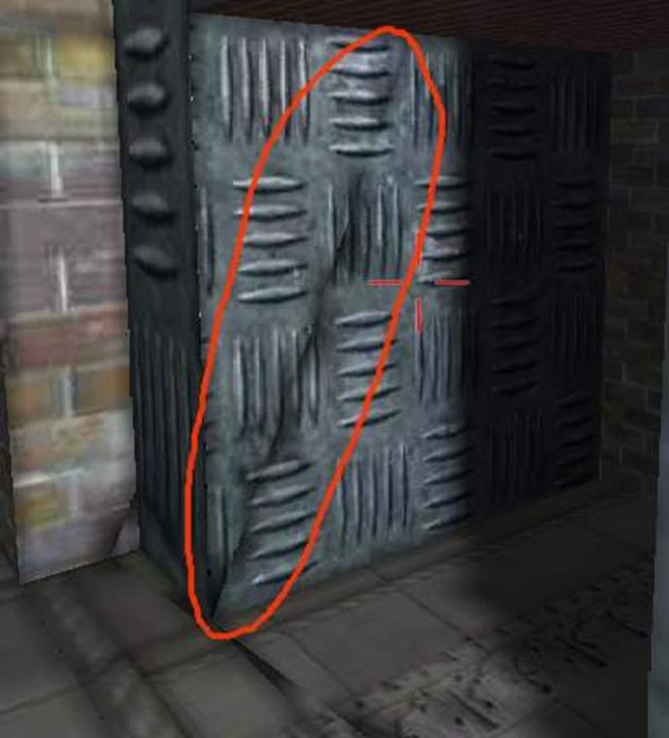
Bleeding due to bi-linear filtering being turned on.

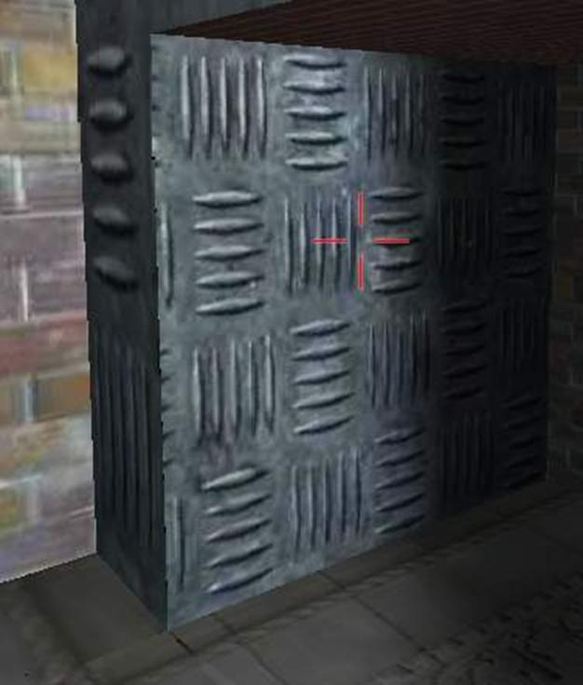
No bleeding even if bi-linear filtering is turned on.
Showing the lightmap:
Now that youï¿½ve taken so much time to calculate the light maps, itï¿½s ï¿½display timeï¿½. Hereï¿½s the code for DirectX 8.1:

// set the appropriate values for the texture stages.
// here Iï¿½m assuming that the device supports two or more texture stages.

SETTEXTURESTAGE(device8, 0, D3DTSS_COLOROP, D3DTOP_SELECTARG1) ;
SETTEXTURESTAGE(device8, 0, D3DTSS_COLORARG1, D3DTA_TEXTURE) ;
// multiply
SETTEXTURESTAGE(device8, 1, D3DTSS_COLOROP, D3DTOP_MODULATE) ;
SETTEXTURESTAGE(device8, 1, D3DTSS_COLORARG2, D3DTA_TEXTURE) ;
SETTEXTURESTAGE(device8, 1, D3DTSS_COLORARG1, D3DTA_CURRENT) ;
// set the appropriate vertex shader.
SETVERTEXSHADER(device8, FVF_MYVERTEXSHADER) ;
SETTRANSFORM(device8, D3DTS_WORLD) ; // set the world matrix

// set the texture for the first stage.
SETTEXTURE(device8, 0, diffuseTexture) ;
// set the texture for the second stage.
SETTEXTURE(device8, 1, lightMapTexture) ;
DrawPrimitive() ; // draw the polygons

Winding up...

- As I have mentioned above, you have to look into Chris Heckerï¿½s article for more explanation on some of the equations I have used.
Some more illustration of using light maps:
To assert the effectiveness of using light maps, a scene has been rendered with different properties / effects. Click on each of the link below to see the images:
• A flat scene without light maps or any lighting.
• Scene rendered with simple vertex lighting.
• A light map that has been generated for the scene.
• Scene rendered with a medium resolution light map.
• Scene rendered with a high resolution light map.
• Scene rendered with light map only, i.e. no diffuse texture.
- Where can you go from here?
• You can use it to light up your ï¿½un-litï¿½ level
• Implement dynamic light mapped lighting .. that would be cool.
• Using the knowledge gained by using the light mapping technique, one can extend it to implement radiosity lighting.
Conclusion:
With the arrival of new monster graphics cards, lighting using lightmaps may become extinct. This article does not provide you any cutting edge technology for todayï¿½s hardware, but it does provide some basic but useful information on the process of creating light maps.
Demo:
An interactive demo has been included with this article where you can see the practical results of this article. I suggest that you download the demo and have a look at the results your self. After you have downloaded and unzipped all the files, look into the readme.txt file for more info. Feel free to play around with the lights. In the demo, you can add and delete static and dynamic lights, change the light properties and build light maps on the fly - and see the results. It's a very good example for using light maps.
Click here to download the demo (~2.1 MB).
(* Editor's note: source code is not included with this demo.)
Credits and Acknowledgements:
Please look at Chris Heckerï¿½s article on Perspective Texture Mapping at:
http://www.d6.com/users/checker
I would also like to thank my company for permitting me to publish this article. I also acknowledge the contributions of all my team members.
Links:
Click here for some info on light map co-ordinate generation.
http://www.flipcode.com/cgi-bin/msg.cgi?showThread=06June2000-LightmapStorage&forum=askmid&id=-1
Some more links to articles or docs about light maps:
http://polygone.flipcode.com/
http://www.flipcode.com/cgi-bin/knowledge.cgi?showunit=79
http://www.flipcode.com/tutorials/tut_lightmaps.shtml
Some Information about the author:
Keshav Channa is the team lead - Engineering, at Dhruva Interactive, India's pioneer in games development. He was part of the team which ported the Infogrames title Mission: Impossible to the PC and has been an integral part of Dhruva's in-house R&D efforts. Previous articles include ï¿½Geometry Skinning / Blending and Vertex Lightingï¿½ published on flipcode.
He is currently working on a multiplayer game for the PC. You can see his work at the Portfolio section at www.dhruva.com
Keshav can be contacted at kbc at dhruva dot com.
Lightmaps (Static Shadowmaps)
by Kurt Miller (16 August 1999)
Return to The Archives

Introduction

This is a tutorial on how to generate and render with static lightmaps, as seen in most modern Quake-ish game engines. We'll start with the very basics. I've made some small changes and clarifications since this document was originally posted, based on reader feedback.

What Is Lightmapping?

For our purposes, lightmapping can be loosely described as the process of using a lightmap, essentially the same as a standard texture map, to store information about the illumination of a surface. Each surface in our 3D polygonal world has its own lightmap, which obviously makes things difficult for memory when you have large worlds. Typically the lightmaps are stored at a lower resolution than the textures, for example 64x64 or 32x32, to keep things trotting along nicely. The lightmaps are combined (multiplied) with the texture either at render time (if you're using hardware rendering) or via a surface cache to produce what appears to be an "illuminated scene". Please note that in this document, I use the term 'surface' interchangeably with 'polygon' or 'triangle' as seen in most 3D engines.
The texture and lightmap are typically not combined into one during the lightmap creation process because even though each surface has its own unique lightmap, it usually does not have its own unique texture. Take for example a room where all of the walls use the same brick texture. If you combined the lightmap and texture for each surface at lightmap creation time, you would be wasting an incredible amount of memory because you'd be making a new copy of the brick texture for each and every surface. That's often impossible (or just plain crazy) in most quake-style games because of the amount of texture re-use among surfaces. In addition, pre-combining the lightmaps and textures wouldn't allow a shadowed area to light up again (for example from a dynamic light in a game.) Here is an example of what a texture combined with its lightmap might look like.
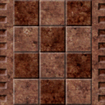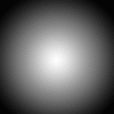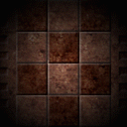
Texture Lightmap Texture * Lightmap
As you can imagine, the resulting image in a game using lightmaps + textures looks far better than textures alone and creates a sense of depth because lightmaps can also be used for shadows. I'm sure you've probably played a game like Quake before, walked underneath stairs or in corners, and noticed that its dark in the places where it should be. That's the sort of thing you can achieve with lightmaps. Imagine that same world with just bare textures. Yuck! ;) The two major drawbacks about this sort of lightmap engine are first the memory requirements, and second, this is only really practical for static lighting. All of the work is done before-hand which makes it fast at render time, but it also makes it a pain to alter the lightmaps. That's not to say dynamic lights are not possible. You can easily use a seperate system for dynamic lighting on top of your lightmap base. Its not often anyway that the whole world will need its lighting information recalculated, so in many cases its worth it to pre-calculate pretty lighting (ie, using a technique such as radiosity).

How Do I Generate Lightmaps?
Please note that this section is on generating lightmaps, NOT lighting. You can use any kind of lighting you want -- lambertian equation, radiosity, whatever -- that's up to you. This section will simply explain one way of doing it. The method I'll describe below is assuming that you're calculating lighting values at each sample point, but given that, it should be easy to extend it for whatever your purpose may be. For starters you need to create a blank new texture for each surface / polygon that you're working with. Lets assume that we're dealing with one surface right now.
You can make the texture's size based on any factors that you want, or even fix it at a certain size. A lot of engines will choose a maximum lightmap size, like 32x32, then calculate the size on that lightmap that the surface will need, keeping in mind a uniform density. If its found that a surface's required lightmap size is too large for that maximum size, the surface would be split into smaller pieces, each with their own lightmap. These considerations are important, because imagine if you had one tiny surface with a full 32x32 lightmap, and one gigantic surface with a lightmap of the same size. Your lit world will look a little strange because of the stretching and compacting of the texture. This topic can get somewhat advanced, so we won't really get into it here. Just keep in mind that several 3D cards require power-of-2 texture sizes. Obviously the same applies for lightmaps since they are in fact just textures.
Now that you have your new lightmap allocated and ready for a particular surface, what we want to do is store a value at each lumel, referenced as a 2D point: lu, lv in the lightmap texture, that represents the illumination value at that location along the surface. Its a little hard to explain, but hopefully you see what I'm talking about.
That's all well and good, but the most common question about generating lightmaps has got to be: How do I go from 2D lightmap coordinates to 3D world space so that I can calculate the intensity value for that lumel? You DO have access to the 3D points at the vertices, so its not entirely 2D texture coordinates to world space -- that would be impossible because many surfaces may have the same texture coordinates. So what you need is the 3D point that matches up with the 2D texture point.
This bothered me for a while because I originally wanted an "exact" solution, using the exact orthogonal uv vectors for arbitrary surfaces; but as it turns out, an "exact" solution in many cases wouldn't look right because the textures don't line up. You want a uniform mapping across all of your surfaces. If you use the 'exact' texture plane of every surface to generate your lightmaps, it'll probably look "sort of" right since the 3D sample points are in the right world position, but you'll also find that its extremely difficult, if not entirely impossible, to make sure the lumels on every adjacent polygon line up. An offset of even a few pixels completely ruins the illusion of smooth and pretty lighting across surfaces. So then, how is it done?
A more common solution is to use planar mapping. If you would like to know more about planar mapping, check out the archives on The Fountain Of Knowledge. Paul Nettle explains (in more than one response) how planar texture mapping works and why it is good. This would be nice to read if you don't know what I'm talking about right now.
To generate the lightmaps, we basically do the following for each surface:

- Determine the primary axis plane based on the absolute value of the normal for this surface.
- Get the min and max (2D vertices) along that plane. This means to use only the 2 relevant coordinate components for this particular plane. For example if you're using the XY plane, only x and y at the vertices count for this step.
- Assign the UV vectors (ie, the normalized vectors pointing 'right' and 'down' respectively. You don't have to use 'right' and 'down', but it makes more sense to trace in those directions as you'll see in the loop below).
- Determine the texture plane origin (p) from the min. This, and the previous step can be done very simply by getting the 3D points based on your 2D (projected) min/max using the equation of the plane. You have only 1 unknown (the missing vertex component), so solving for it is trivial.
- Determine the u and v lengths (max-min)
- And finally, determine lightmap coordinates:
(for each vertex) ltu=((pu - minu) / ulen) and ltv=((pv - minv) / vlen)
where pu and pv are the x and y in PLANE space (not world space).
pu and pv are nothing new, they are the 2 relevant components at the vertices for this particular plane. The 'x' and 'y' in relation to the plane.
- Now you have the UV vectors and lightmap coordinates to do whatever you need. The actual sample point determination for each uv when generating the lightmap might look like the following in psuedo-code, unoptimized for clarity:

usteps = ulen / [lightmap_w];
vsteps = vlen / [lightmap_h];
for(int ly=0; ly < [lightmap_h]; ly++)
{
for(int lx=0; lx < [lightmap_w]; lx++)
{
xs = uvec * (lx * usteps)
ys = vvec * (ly * vsteps)
sample= xs + ys + p
// ... actual lighting calculation at this sample point
// ... store the result at position (lx, ly) in the lightmap;
}
}
The sample point is in world space and that's what you'd use for the lighting. There are many obvious optimizations that you can make to the above, but the idea remains the same.
I hope I didn't make any mistakes in the above explanation. If I did, its likely something I typed wrong or forgot to type because the algorithm works (as far as I know ;). This approach is very easy and the results look nice. Obviously the worst case would be when a polygon is slanted at 45 degrees to some plane, but it still doesn't look too bad. I was talking to a fellow coder, Luke Hodorowicz, about an approach like this that he's working on as well and he agrees that the skewing isn't really that noticeable even in those worst case situations; especially in conjunction with techniques like bilinear filtering.
Again, the lighting performed at that sample point can be anything you wish, but to get your feet wet, if you want to use the lambertian lighting equation, you can: take your sample point and subtract that from the light position, normalize the result, then dot it with the (normalized) polygon normal. That's the bulk of the calculation. That dot product is the important one for lambert, and you can use it with as many other factors as you'd like, for example I have a distance/radius ratio in there. That's up to you -- experiment with it or look up the exact formula if you seek exactness. Often times in game programming, coming close enough to 'realistic' but fudging it with a hearty helping of 'looks good' sauce works nicely.
Here's a quick example that I threw together for illustration purposes only:
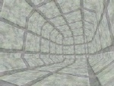 x 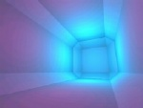 = 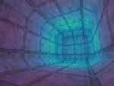
The above scene is a triangle mesh with 77 verts and 44 faces. There's a very strong blue light and a faint purplish light as well. Note the difference in "realism" or "depth" between the plain textured version and the final version.
Rendering With Lightmaps
I must admit that when I first implemented lightmaps several monthes ago, I was already using 3D hardware for rasterization which means I've never written a surface cache for software rendering, so you'll have to look elsewhere for information on that. Its a straight-forward idea, so it shouldn't be overly difficult, but I won't describe it here. Check the reference section at the end for links.
I suppose you could still use a surface cache if you're using hardware, but its not really all that neccesary. Most 3D hardware these days can perform single-pass multitexturing (or you can resort to two seperate passes). This is what I use at this time. You simply need to set up your multitexturing function to multiply the texture and lightmap together at render time and you'll have your nicely illuminated surface.
Other Questions & Answers
How do you generate color (RGB) lightmaps?
Piece of cake. One way is to simply generate a "red", "green", and "blue" lightmap seperately (in the same loop of course) then combine and clamp them when you're finished. Using this approach you can easily use arbitrary rgb colored lights.
How come I can see my lightmaps just as clearly as my textures after the final render?
Heh, take a look at this screenshot... a portion of one of my very first lightmap shots (quite old).
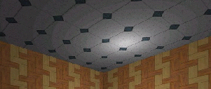
That's part of the ceiling in a small world. See how you can clearly see the rings of the lightmap? I started getting nervous and began to think I should dither/filter/blur/something them. The reason for this is not that I was doing anything wrong. The answer, which my buddy Mr. Nettle mentioned to me a while back, is simply because those textures aren't textured enough. I grabbed those textures from a 'free web textures' site, and thus they're aimed at web site backgrounds, not games. If you view textures from various games such as Half-Life or Unreal, you'll noticed how very textured they are. This greatly improves the image quality when rendering with lightmaps. After kicking myself, I downloaded some free GAME textures to play with (references at the end of this doc) and of course everything looked beautiful. You can filter your lightmaps, and if you're using basic shadows (next question..), you definitely should. But to be honest, they still look great without it if your textures are sexy enough. At least to this coder.
How do I handle shadows?
That completely depends on how you're doing you're lighting. If you're using simple point light sources and simple lighting equation calculations, you can easily determine where shadows should be by checking, for each point in the lightmap, whether the light actually reaches this particular surface at this particular point (ie, if any other polygon in the level is blocking it or not). That involves much ray casting and many intersection tests which means its quite expensive, but keep in mind that this is all still computed offline and stored in the lightmap hence it won't really affect your actual rendering performance. This process can also be optimized fairly well with a few simple 3D tricks. If you use this approach for shadows, I highly recommend that you filter your resulting lightmaps to get rid of the hard edges and give the scene a much more natural look.
This is of course not the only way to determine shadows.
How do you do volumetric fog with lightmaps?
This is another easy add-on when using a lightmap-ish architecture. You can use a seperate set of lightmaps (usually much smaller than the texture because the fogging is view-dependent and thus expensive to calculate repeatedly) and store fogging values, which are usually alpha values, then combine it with the actual surface at render time giving the illusion of volumetric fog. The fog values are determined by a few simple intersection tests with your fog volume. For more information, check out the the reference section at the end of this doc.
Closing
In this doc, I've attemped to explain the idea behind lightmapping as it is used in the majority of the modern 3D game engines currently on the market (fps engines anyway). The lighting itself and implementation details/concerns vary and are up to you, but hopefully you now understand how to generate and use lightmaps. I make no claims as to the validity of the info in this file. Its mostly from personal experience, so I could be wrong. There are as many ways to do this as there are kernels of popcorn on a crowded movie theatre floor, so if you've got a better approach or suggestions, by all means please let me know. Thanks for reading.
Sources / Further Reading
Color & Lighting by John DiCamillo
This is literally the only other site I ever remember seeing on the internet with solid info on light mapping until very recently. It does a nice job explaining the concepts, but its a few years old (using palettes and software rendering) and the psuedo-code has some html problems. Other than that, definitely check this one out if you're looking for a good introduction to lightmaps.
The Fountain Of Knowledge: Lightmaps
The Fountain entry on lightmapping by Paul Nettle has some solid information on planar mapping and the fundamentals behind lightmapping in response to a question that someone sent in. You can find this in the archives section.
PolyGone: Various Lightmap Docs
I came across these docs on Tobias Johansson's web site only very recently. There are some interesting ideas about light mapping including a piece by Warren Marshall which describes how to obtain the world space sample point using a bounding box. I haven't really read over these docs in detail yet, but if you're interested, you can find them there.
Spherical Volume Fog
This document covers volumetric fog (using fog maps) in much more detail than I mentioned.
The Texture Studio
Most of the textures I use in my engine demos came from this site (with permission). He's got some excellent game-ish texture pack releases available for download. Very highly recommended.
KAGE Document On Surface Caching
Here's another doc written by Paul Nettle, this time about surface caching in the KAGE engine. Again, I don't use a surface cache, but if you're interested in the topic then you might want to try here.
Also, greets/thanks go out to various people that I've talked to about lightmaps and related topics.

